SOUTH OF THE ALPS • Ambra Albek (vn); Fiona Albek (pn) • EROICA 3450 (75:14)
FALLA 7 Canciones pupulares españolas. LUCCHETTI Fantasy on Themes from Tosca. TURINA Violin Sonata No. 1. El Poema de una Sanluqueña: La Canción del Lunar; Alucinaciones. ALBÉNIZ Hojas de Album: Malagueña; Canción Catalán; Tango. POULENC Violin Sonata

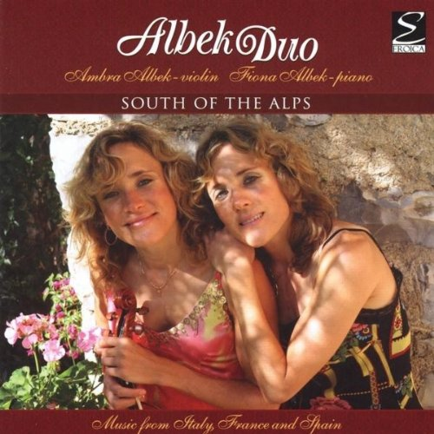
This is a superbly produced and executed disc. The Albek Duo (identical twins Ambra and Fiona) provide a varied disc of music performed with real panache. Photos of the duo adorn the inside front cover, taken at various international venues (Rotterdam, Salzburg, Lugano, Vicenza), and they boast a very professional website (albekduo.com/en/index.php).

They begin with Falla’s famous Spanish Popular Songs, arranged by Alessandro Lucchetti (“Seguidilla Murciana,” the second movement) and Paul Kochanski (the rest; Kochanski omitted this movement from his arrangements, so the Albeks have plugged the gap). All arrangements are skilled, allowing one to revel in the antics of the sprightlier songs and to languish in the melancholy of the slower sections (“Nana” is simply beautiful, as are the stratospherically high passages for violin in “Canción”).

Lucchetti might have only arranged one of the Falla songs, but he has a whole spot to himself in his Fantasy on Themes from Tosca. This is a remarkable fantasy, written in 2009 specifically for the current performers. Puccini’s long lines suit the solo violin well, whether in the impassioned higher register or the smoky, sensual lower. Drama and adrenalin both run high in this performance. Ambra provides a magnificently hushed “Vissi d’arte” (Fiona’s chordal accompaniment is just a tad pedestrian). Incidentally, the Albeks’ website lists a number of concert programs, of which the present disc is one. Others include further works by Lucchetti and by William Perry (see my interview with Perry in this issue).

The Turina is imbued with tenderness. The first movement’s second subject is as tender and wistful as could be imagined from Ambra, while the farruca rhythms of the finale are wonderfully rendered. The Albéniz is a magical account, full of atmosphere (the central “Canción Catalan” is beautifully managed from both parties). Those wishing to investigate Turina’s sonatas further might wish to locate Felix Ayo and Bruno Canino’s disc (on Dynamic, reviewed by James Miller in Fanfare 23:1). The Poulenc sonata similarly highlights the lyric strength of the Albeks, particularly in how the reflective sections of the first movement point toward the hushed delivery of the central Intermezzo. The Albeks honor the typical Poulenc circus-buffoonery of the finale splendidly while maintaining something of an aura of mystery.
Finally, two Turina pieces offered, perhaps, in the spirit of encores. Both are evocative and absolutely delightful. A splendid recital.
Colin Clarke

